Muscles, Bones & Joints INVESTIGATION | Name:______________________ (______/30)

Study the images of a long-bone

1. a) Name the structures labelled:

A: medullary cavity or yellow bone marrow cavity

D: articular cartilage (covering)

b) What type of bone is found at position

B: spongy/cancellous bone

C: compact bone
(4 marks)

2. What would you expect to find filling structure A?

yellow bone marrow (will accept fat) (1 mark)

3. What is ONE function of structure D?

provide smooth surface to reduce friction,
cushion impact
produce synovial fluid (1 mark)

4. Explain the functional benefit of the way structure B is “designed”. Why is it not solid?

gaps make it lighter (1)
strands and plates increase the strength for weight bearing
(2 marks)

5. Name ONE long bone in the human body

femur, humerus, tibia, fibula, radius, ulna (1 mark)

6. What are the TWO types of joints this bone will make at either end?

Hinge, ball & socket (femur & humerus)
Gliding joint & slightly moveable joint/cartilaginous (tibia)
2 x slightly moveable joints/cartilaginous (fibula)
2 x pivot joints (radius)
http://www.pediatric-orthopedics.com/Topics/Bones/Forearm/forearm.html
(2 marks)

Study the images of a dissected chicken wing

7. Draw in the flexor and extensor muscles as well as the tendons and cartilage on the diagram below that are required to move the wing

Use coloured pencils to shade in your additions and match this with the colour key below.

Tendon

Flexor muscle

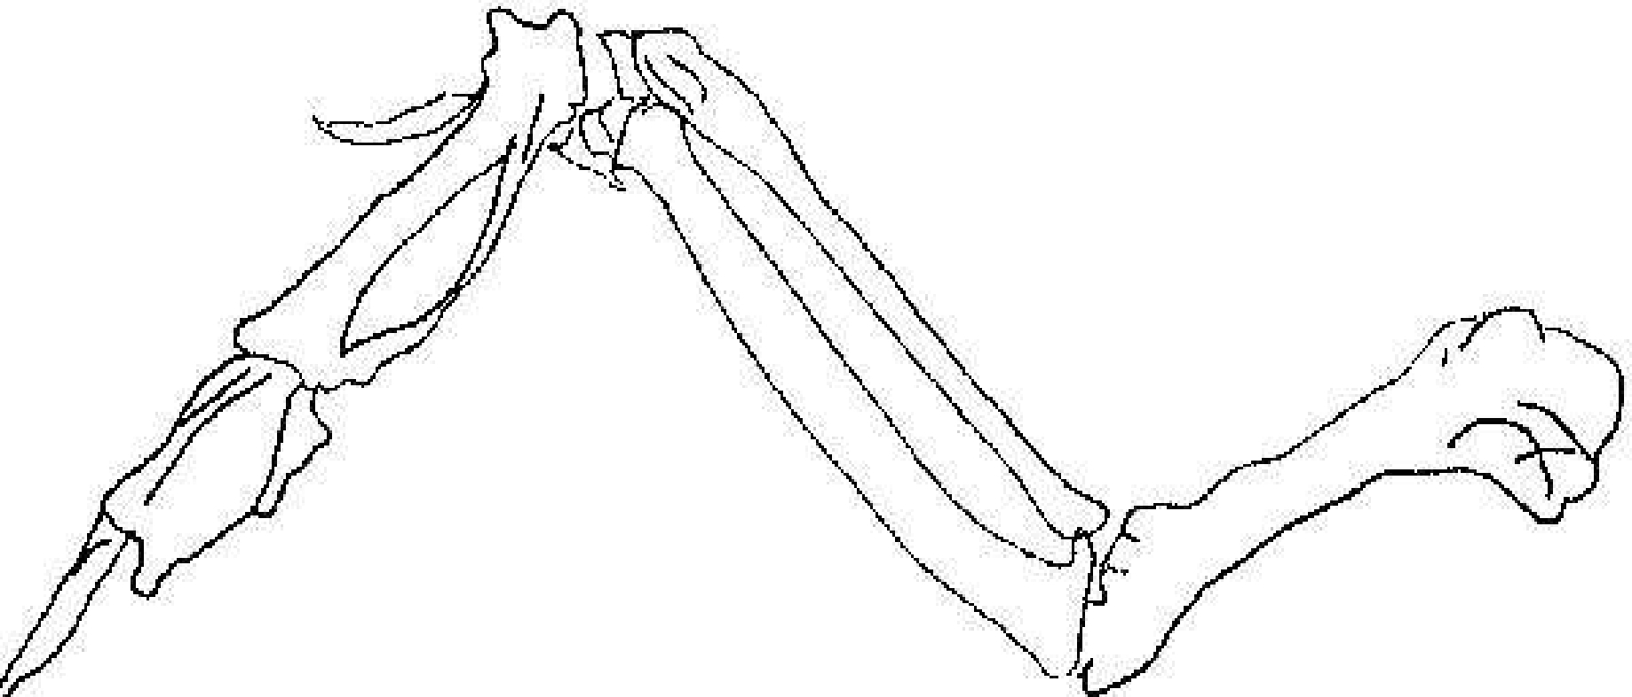
Tendon

Tendon
Cartilage
Tendon

Extensor muscle

Colour Key

 = Flexor  = Extensor  = Tendon  = Cartilage
(4 marks)
8. Label the Humerus, Radius, Ulna, and Phalanges on the chicken and human bones on the diagrams below.
radius

humerus
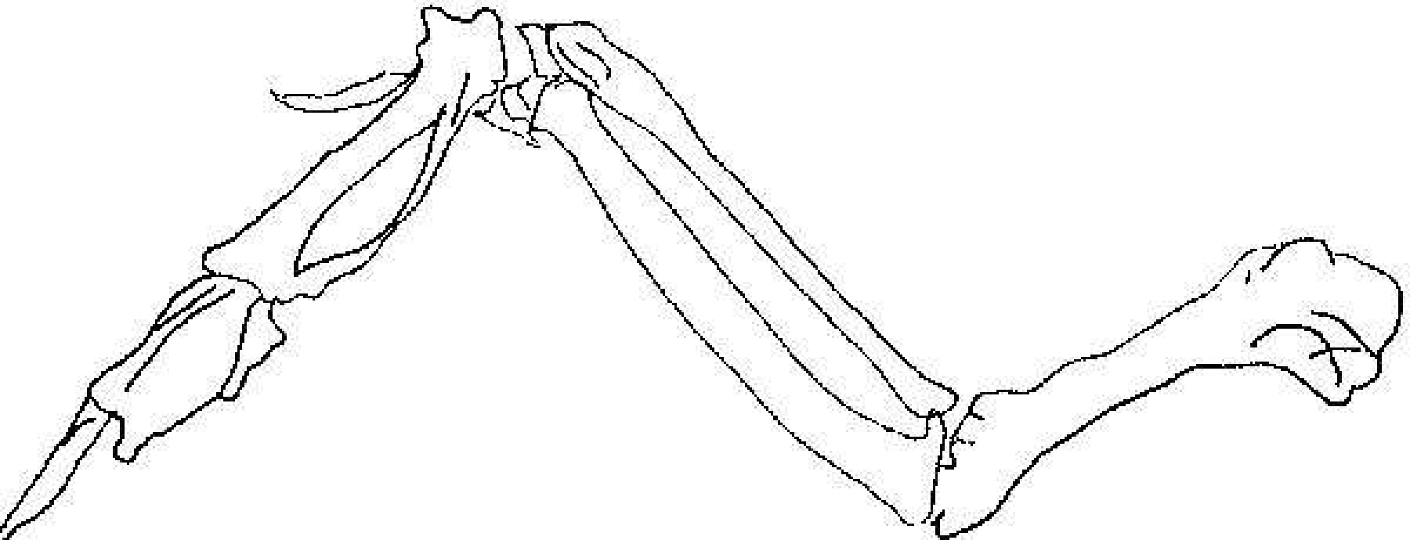
phalanges

ulna

ulna
humerus
phalanges
(4 marks)

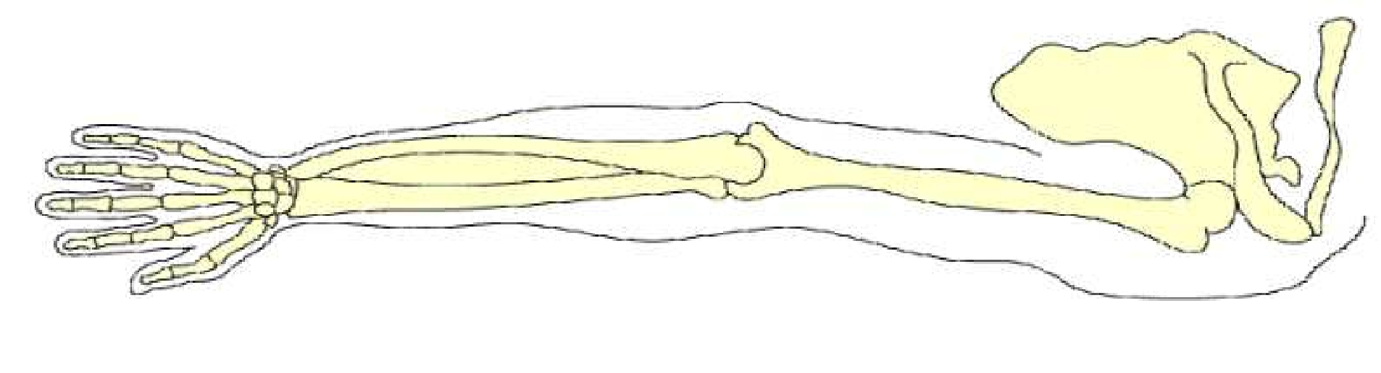

radius

(4 marks)

9. Why are some bones irregularly shaped, or have notches, as opposed to smooth, rounded ends?

increases surface area (1) for greater muscle attachment (1)

(2 marks)

10. Based on your observations, explain the roles of muscles, tendons, and bones in the back- and-forth movement of the part of the chicken wing labelled X.

X

(5 marks)
When the bone moves inward: The muscle (adductor/flexor) shortens in length (1)
The abductor muscle lengthens (1)
Tendons pull on the bone (1)
This pulls the bone inward (1)

When the bone is pulled outward: the muscle (abductor/extensor) contracts, the flexing muscle relaxes
Tension on the tendon decreases (1)

(must distinguish between back & forth, and not just describe one direction of movement)

(must use one of the terms in brackets to specify which muscle they are referring to)

any 5 marks

